Question 1. Retrieve all customers who have placed at least one order
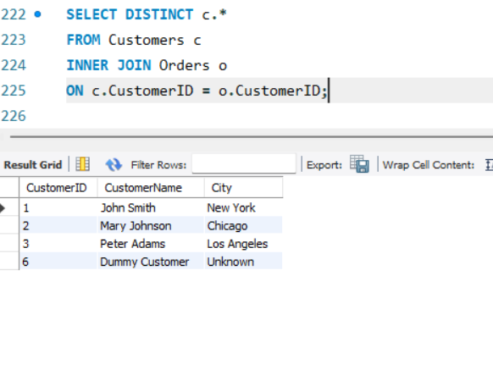

Question 2. Retrieve all customers and their orders, including customers who have not placed any orders.

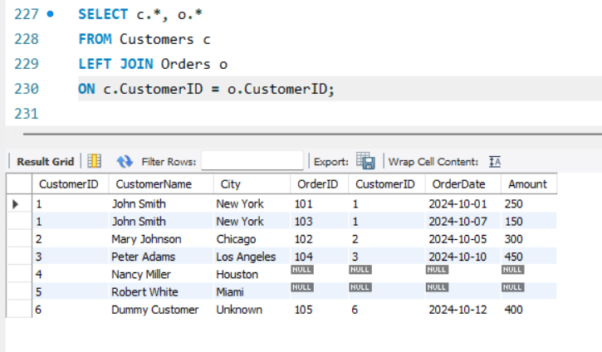

Question 3. Retrieve all orders and their corresponding customers, including orders placed by unknown customers.
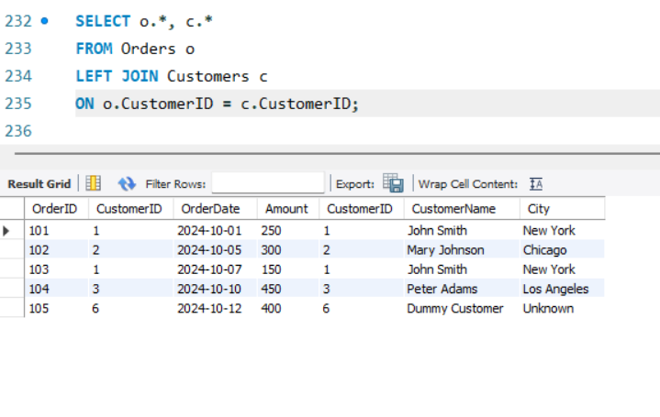

Question 4. Display all customers and orders, whether matched or not.
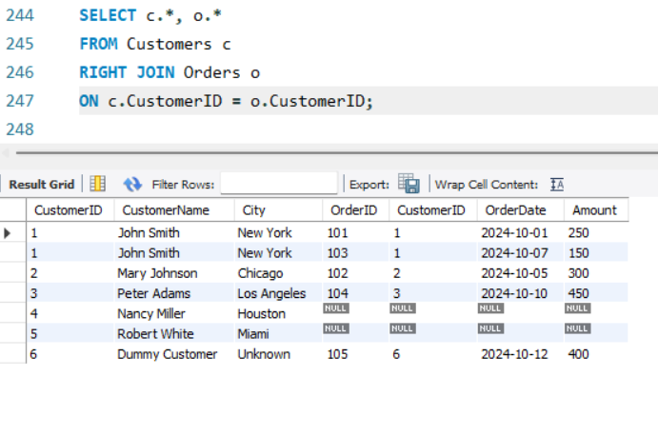

Question 5. Find customers who have not placed any orders
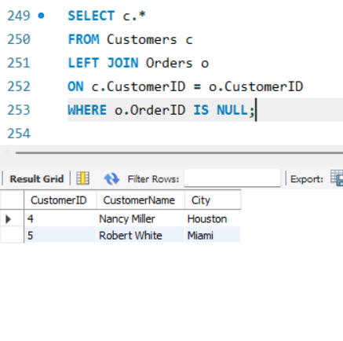

Question 6. Retrieve customers who made payments but did not place any orders.

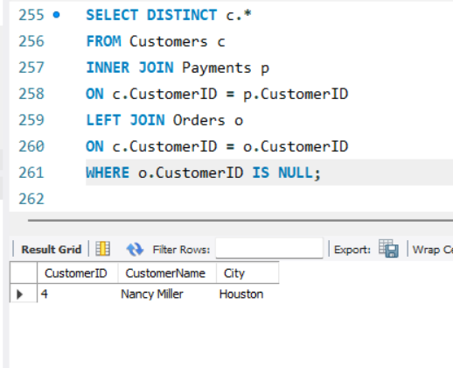

Question 7. Generate a list of all possible combinations between Customers and Orders.
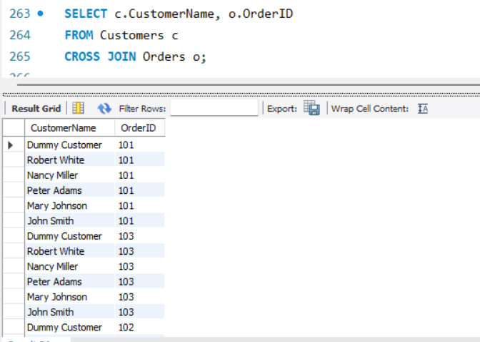

Question 8. Show all customers along with order and payment amounts in one table.
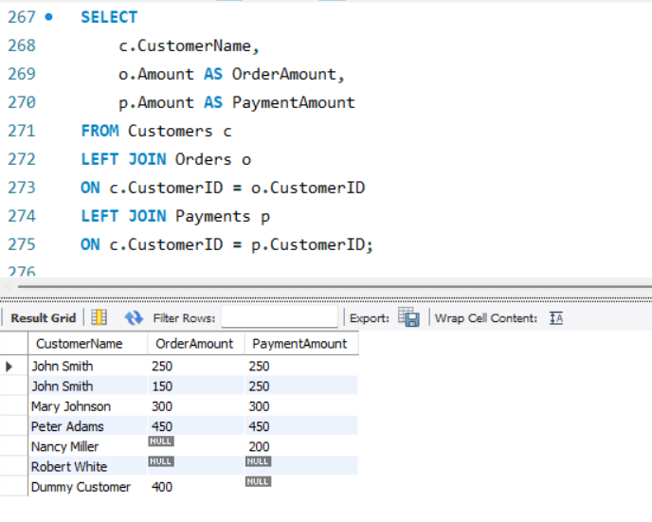

. Question 9. Retrieve all customers who have both placed orders and made payments.
